**VPN LOGS**

1. Filter Firewall Event logs.

index="fortinet" sourcetype="fortigate_event"

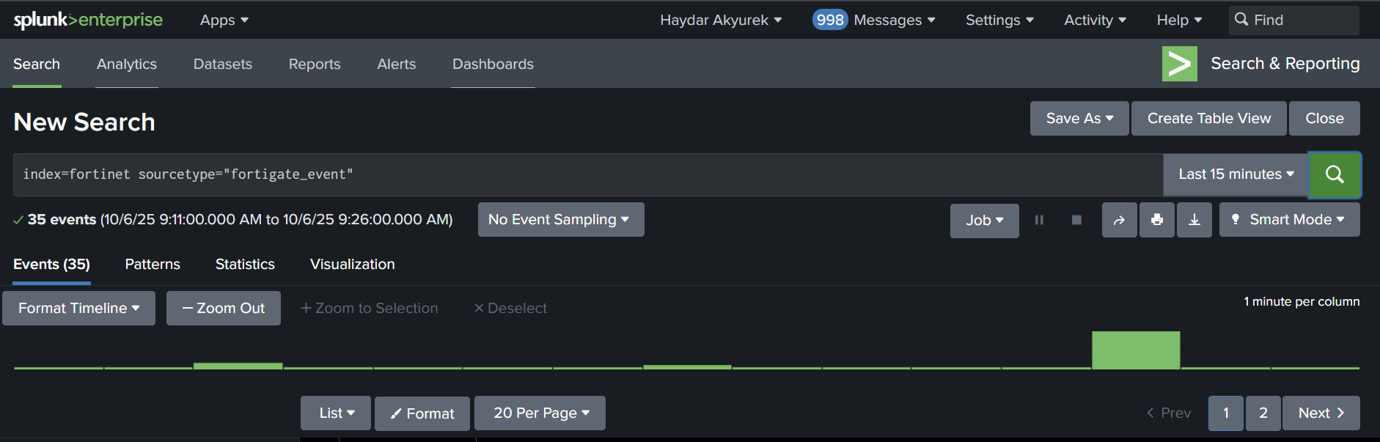

2. List VPN users and their assigned internal IP addresses in the last 15 minutes.

**index=fortinet sourcetype="fortigate_event" | stats count by xauthuser assignip**

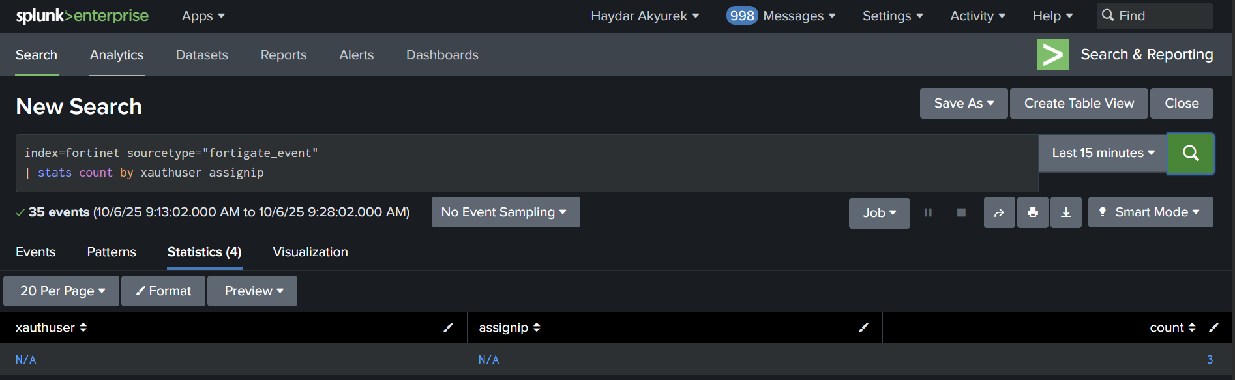

3. List VPN users and their external IP addresses in the last 15 minutes.

**index=fortinet sourcetype="fortigate_event" xauthuser!=N/A earliest=-1h latest=now**

**| stats count by xauthuser, remip**

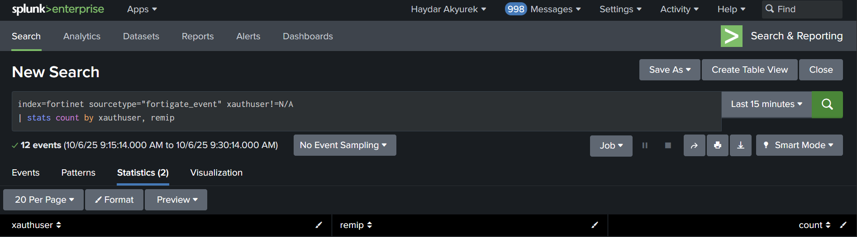

4. List VPN users and their internal IP addresses that have failed login attempts in the last 24 hours.

